Key Indicator- 2.5. Evaluation Process and Reforms (30)
Metric  No. |  | Weightage
2.5.1.  Q_{l}M | Mechanism of internal assessment is transparent and robust in terms of frequency and variety  A rigorous effort is made to maintain the quality of internal semester question paper and the assessment process. The internal assessment marks for theory is based on mid-semester examination conducted as per the institute’s academic calendar usually after 9 to 10 weeks of commencement of semester. The time table for mid-term examination is displayed at least 10 days before MSE.  The paper setter has to get a paper moderated by a dedicated team of moderators. The syllabus content, coverage of Course Outcomes (CO), difficulty level, formatting, grammatical errors, length of paper and the justification of marks is assessed by moderator. Paper setter has to map each question with CO while submitting paper to moderators. After moderation, the course coordinator prepares solution and evaluation scheme. The assessment is completed after 5 to 6 days of examination and the assessed answer sheets are shown to students.  If student/s is/are not satisfied with an assessment, he/she can approach head of department with a request for re-assessment on the same day of an answer-sheet display. The head of department reviews the same and if found genuine, he/she appoints a subject expert other than the primary assessor. If the difference in the marks after reassessment is less than 10% (i.e. if total marks are 30 marks, then less than 03 marks of difference and if the paper is of 20 marks then less than 02 marks of difference) then no change of marks will be declared. But if the difference is more than or equal to (≥) 10%, the higher marks obtained either in primary assessment or reassessment is considered.  The final internal marks are uploaded on university portal at the end of semester and the same can be viewed by students. In case of any query/correction, concerned student approach course coordinator to correcting his/her marks. The course coordinator requests GTU coordinator to unlock the portal for concerned course and the correction is made within the time frame provided by University.  File Description:  - The flow of conducting Internal examination (MSE)  - Link for additional information: Portal URL: http://me.gtu.ac.in/,  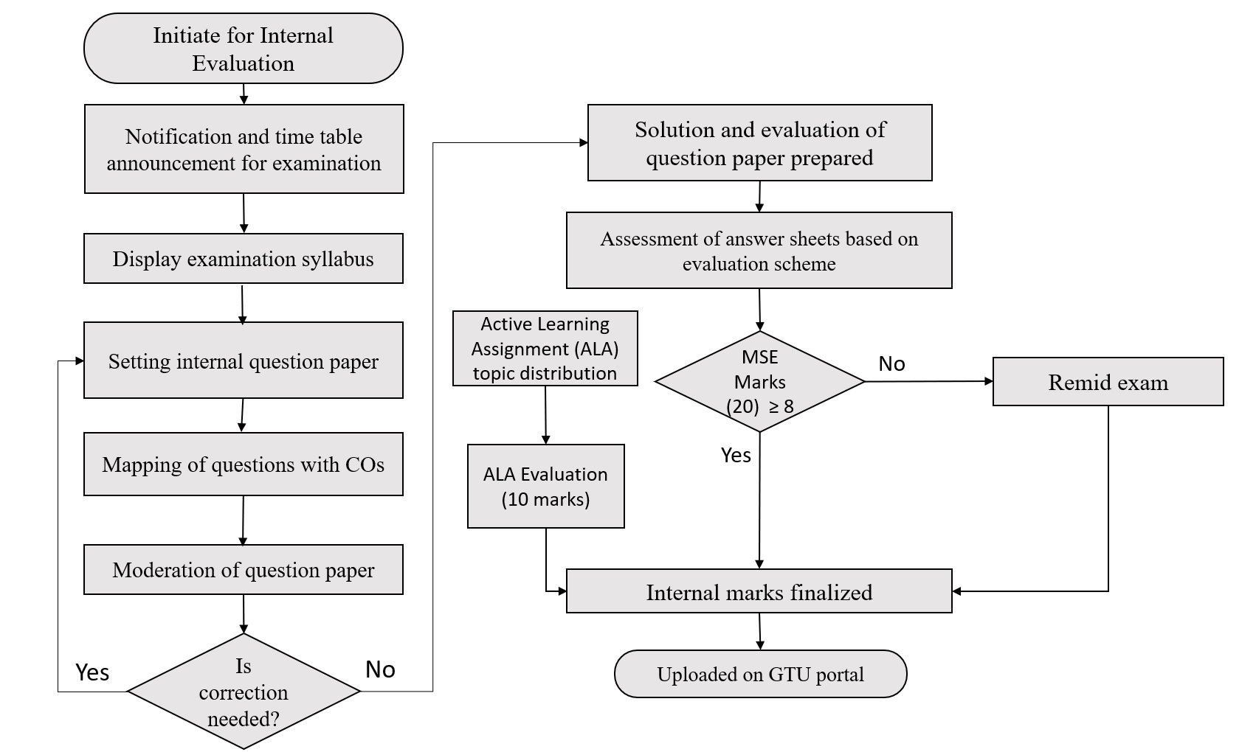 | 15
2.5.2.  Q_{l}M | Mechanism to deal with internal examination related grievances is transparent, time- bound and efficient  To ensure that the examinations are conducted in a punctual manner, Centre in charge nominates a senior professor as a flying squad member. The general guidelines for Flying Squad are as follow;  • Inspect the examination halls and verify the seating arrangement. If the seating arrangement is improper, he/ she shall inform the numbering supervisor and get it amended.  • Observes that the Sr. supervisor/s is/are active. Similarly, visit the blocks and exercise check for the proper conduct of examination and discouraging malpractice.  • Keep vigil of all aspects of the conduct of examination at the centre. Report the cases of malpractice/ misconduct, if any, to the concerned examination official and report the same in 'flying squad observation report'.  • The Flying Squad shall monitor all aspects of the conduct of examinations and ensure the examinations are conducted in a punctual manner.  • The committee at the end of their visit shall fill up observations in a form and submit the same to the centre in charge in a seal pack cover.  Any unfair mean (UFM) reported during examination is reported to the examination section. The statement of concern (flying squad, GTU coordinator, senior supervisor, block supervisor, subject expert and examinee) is taken in case of UFM along with CCTV footage. The UFM hearing meeting is scheduled within one week after the respective examination. The UFM committee comprises of GTU coordinator, flying squad member/s, concerned head of department and centre in charge. The policy of UFM is framed in line with the university policy.  Other than Students' internal examination related grievances, students approach the exam section for university exam-based grievances i.e. correction/updating grades in mark-sheet, an extension of the term, a refund of successful reassessment, etc. The examination takes appropriate action within two days of application is received. The members of examination section meet every month to review process of examination section and grievances recorded and action taken.  File Description:  - Internal UFM policy  - File related to grievances | 15

